**Algorithm and Data Structure**

**Project Report**

**Pacman**

Lecturer : Nguyễn Thanh Tùng

Group : IU 007

Members:

* Tô Bá Thanh Tùng – ITITIU16061 – Leader, Graphics, Control
* Nguyễn Thiện Tuấn Ngọc – ITITSB16002 – Graphics
* Đoàn Trọng Nhân – ITITIU16011 – Searching Algorithm

Link GitHub: <https://github.com/ToBaThanhTung/pacman-game>

1. Introduction

Pac-Man, stylized as PAC-MAN, is an arcade game developed by Namco and first released in Japan in May 1980. It was created by Japanese video game designer Toru Iwatani. It was licensed for distribution in the United States by Midway Games and released in October 1980. Immensely popular from its original release to the present day, Pac-Man is considered one of the classics of the medium, and an icon of 1980s popular culture. Upon its release, the game—and, subsequently, Pac-Man derivatives—became a social phenomenon that yielded high sales of merchandise and inspired a legacy in other media, such as the Pac-Man animated television series and the top-ten Buckner and Garcia hit single "Pac-Man Fever". Pac-Man was popular in the 1980s and 1990s and is still played in the 2010s. (Wikipedia)

Pacman game-play is simple but not easy, player plays the main character,aka Pacman, which is the yellow circle with opened mouth. The mission to win each stage is to collect every pill in the maze and not get caught by 4 ghosts.

1. Coding
   1. Engine

In this project, we use the game making library which is GDXLib. This library is built for making 2D game.

For this game, we use physics package, Box2D package and Tiled Map package.

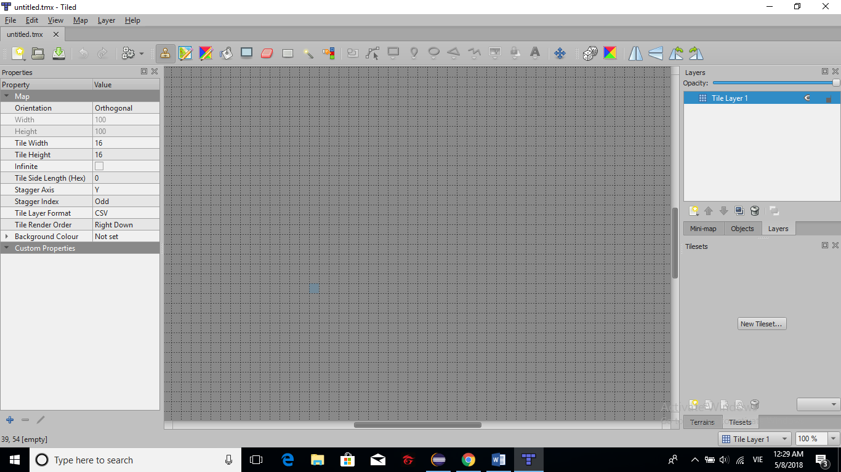  
(Tiled Map user interface)

* 1. Algorithm

For this game, we built a simple AI for 4 ghosts. We use A* algorithm for ghosts to find the Pacman.

This Algorithm is the cobination between the Breath First Search and Dijkstra Algorithm.

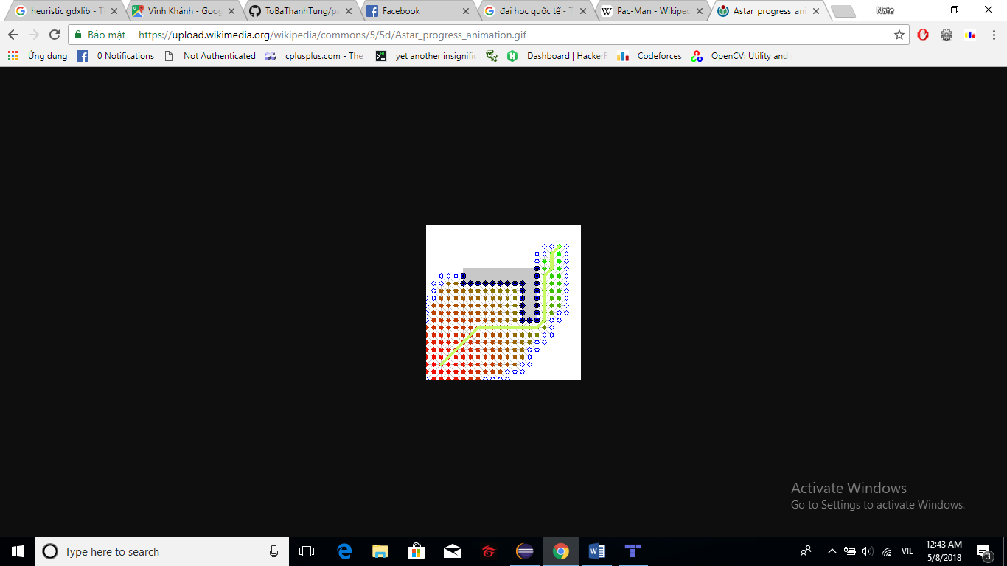

(The A* algorithm)

While working on this game, we read a topic about A* using binary heap and decided to use this algorithm.

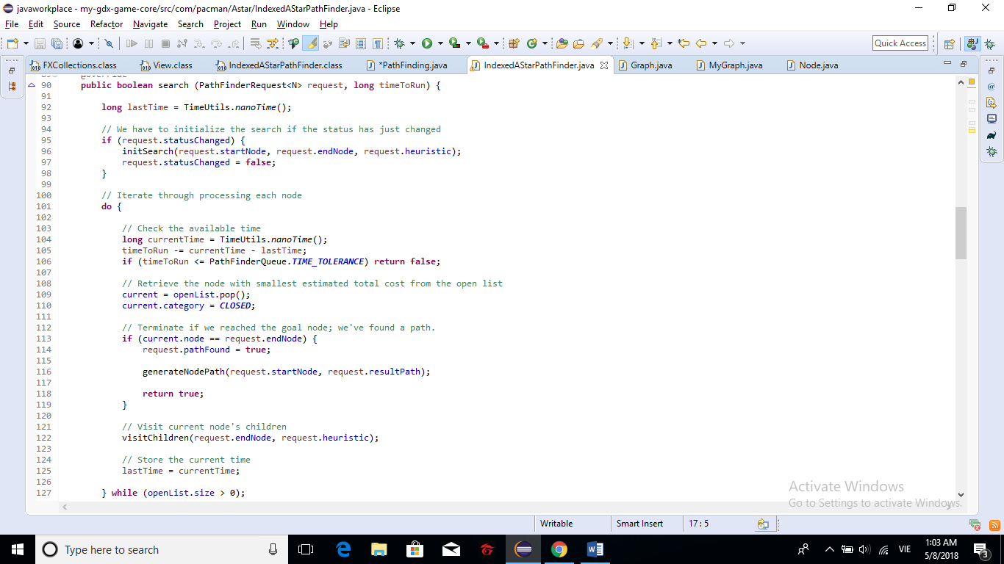

Finding node path in the IndexedAstarPathFinder class

* 1. Graphics

With tiled Map and other packages, we created the Pacman interface.